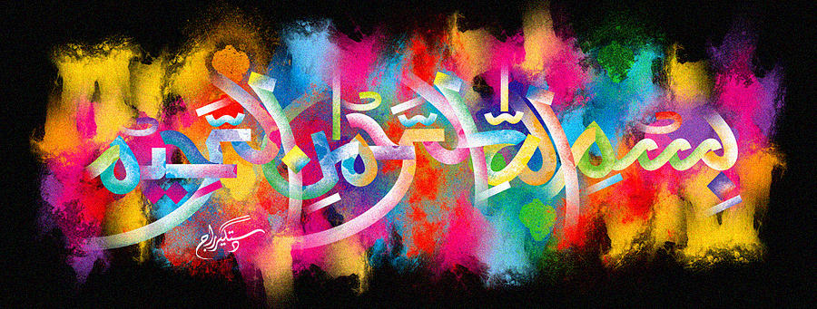
The Miracle Black Plum [B] of 19TH October 2015
The Exclusive Islamic Miracle Photographs of Dr Umar Elahi Azam
Monday 19thOctober 2015
Manchester, UK

Introduction
There was one impression of The Name of Allah in the cross-section of this plum.
